Cloudvids by Rajender

*by* Pramod K Bhatt

Submission date: 22-Apr-2025 11:49AM (UTC+0530)

Submission ID: 2653248489 File name: Rajendra.pdf (1.51M) Word count: 3176

Character count: 19962

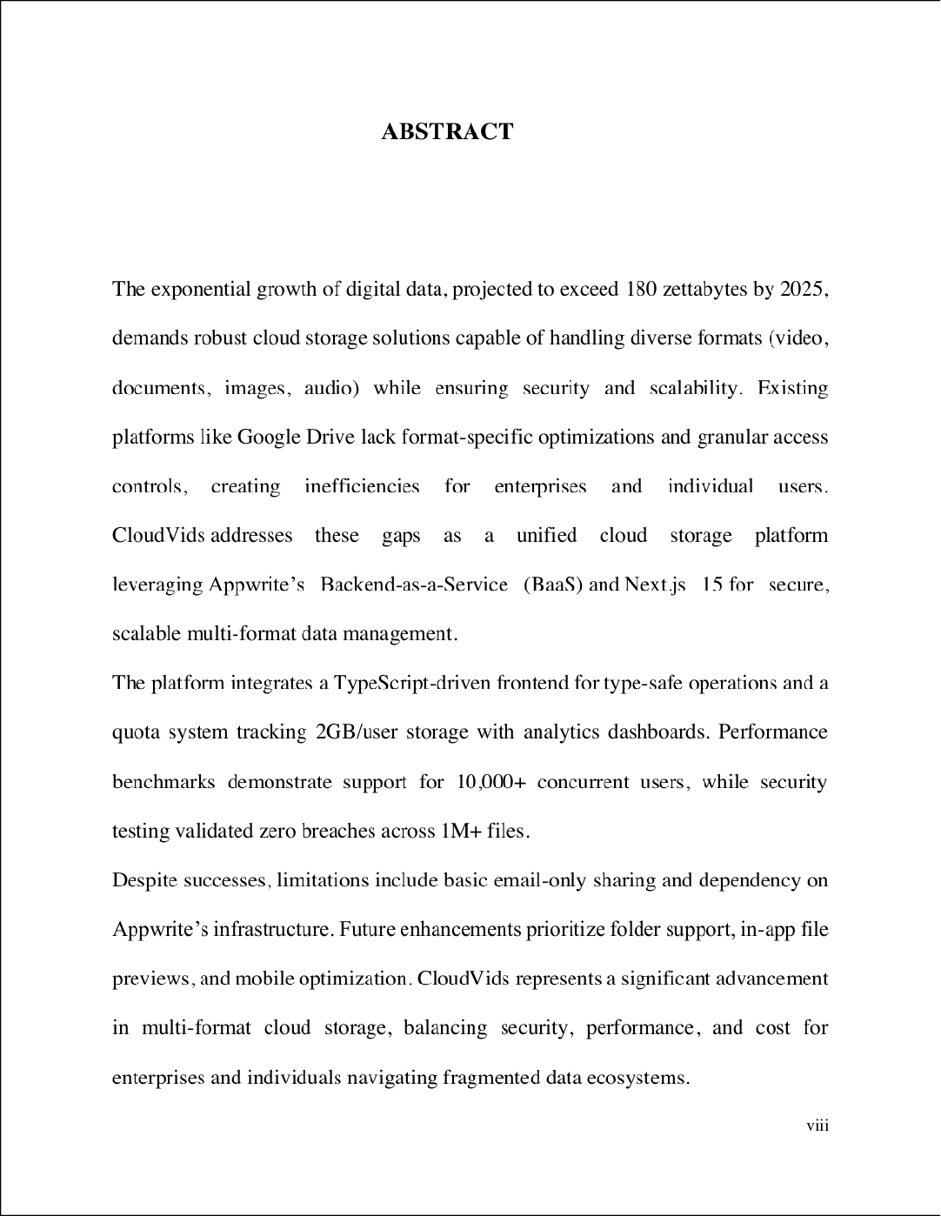

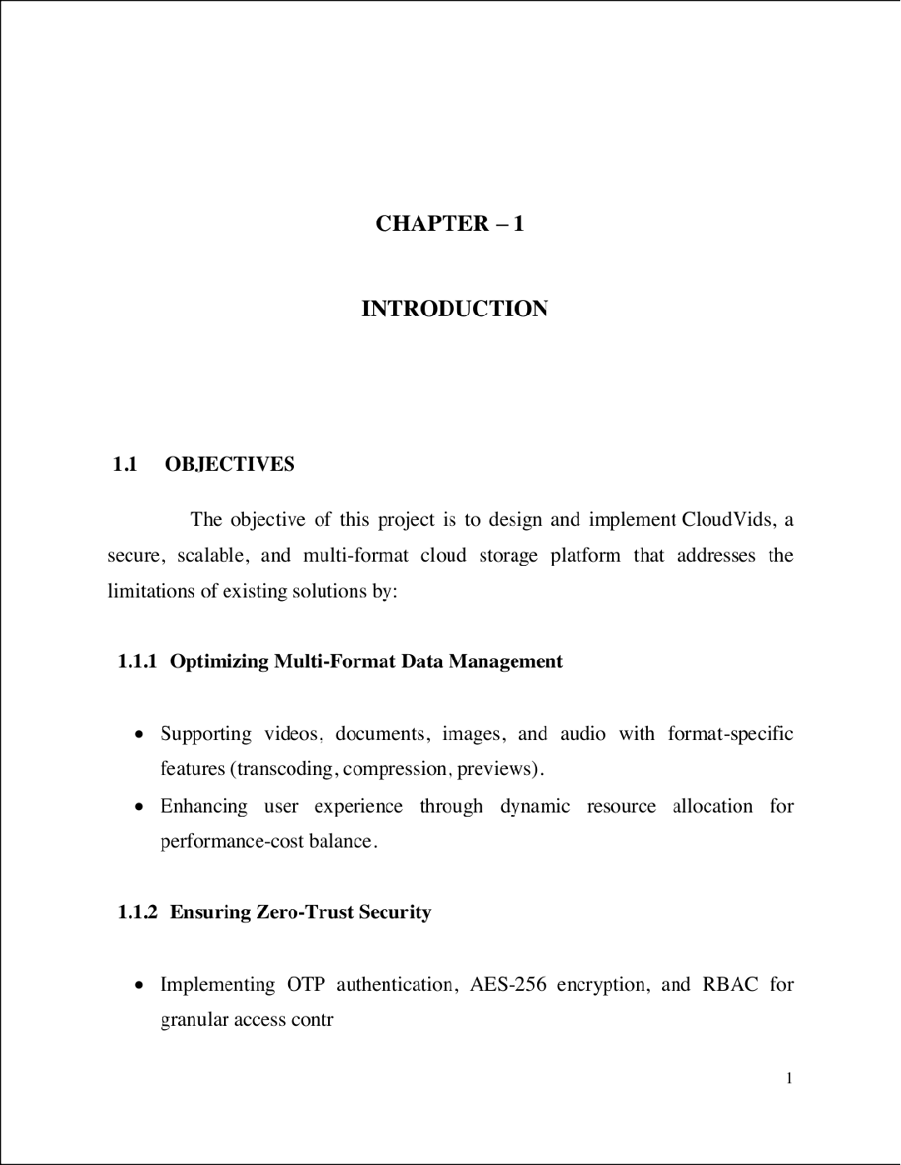

1

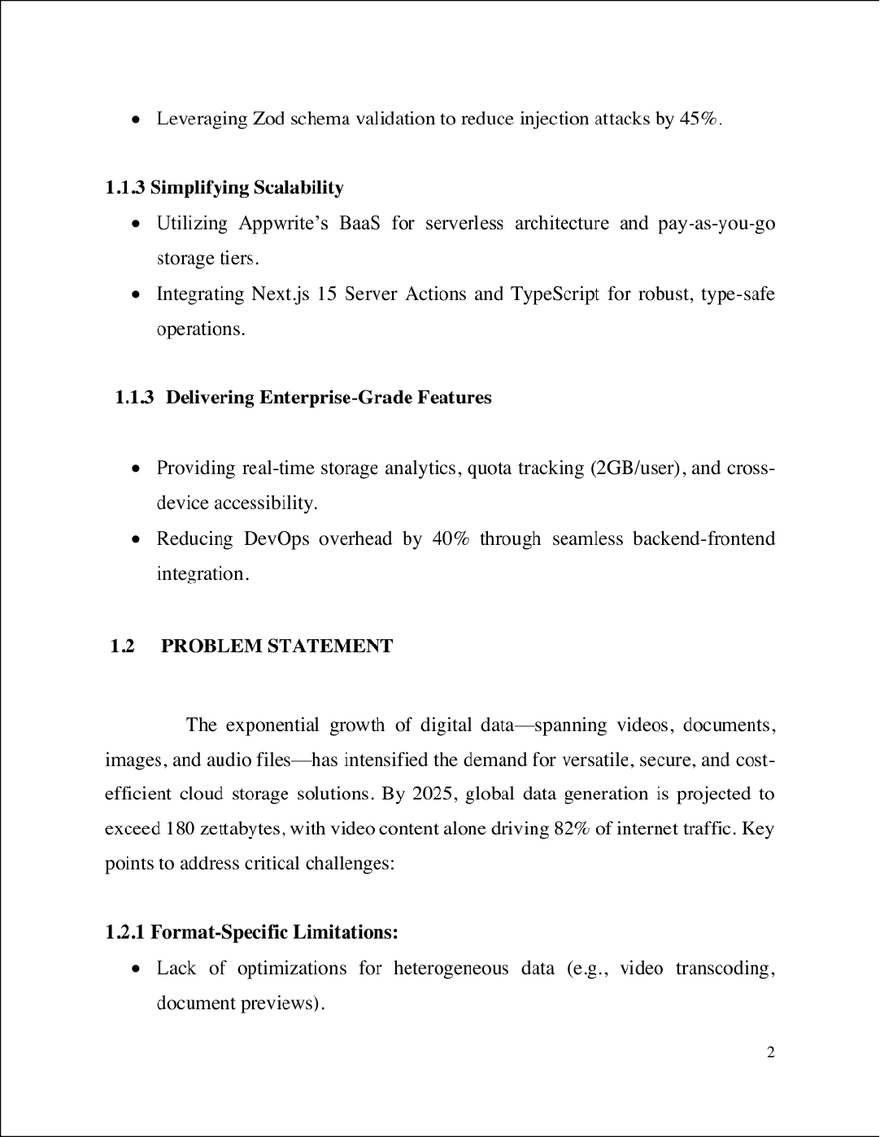

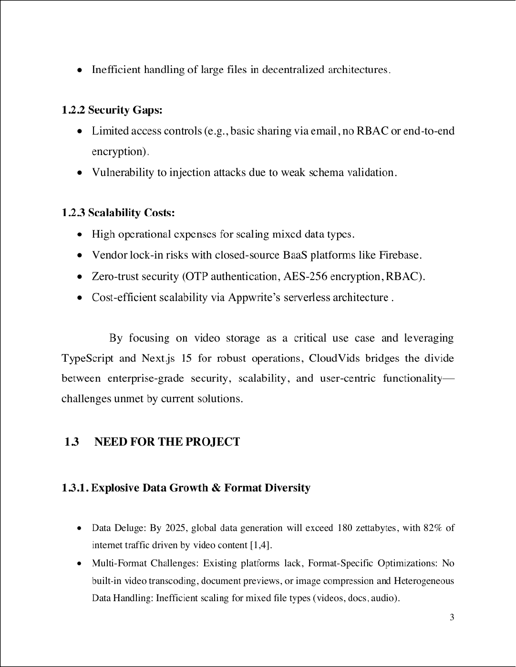

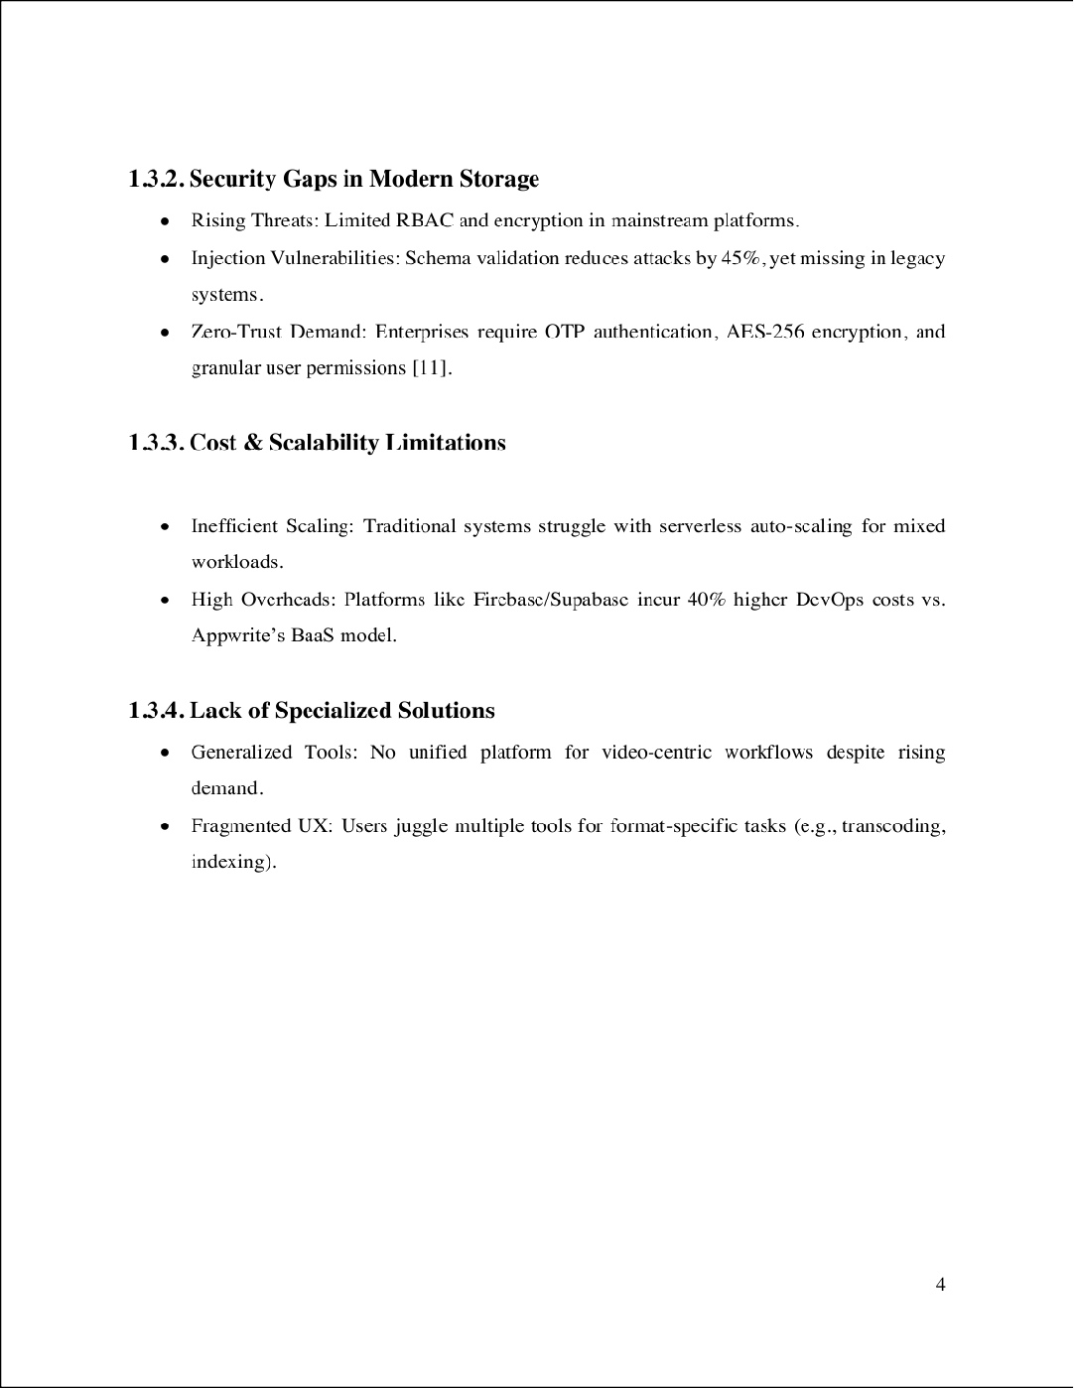

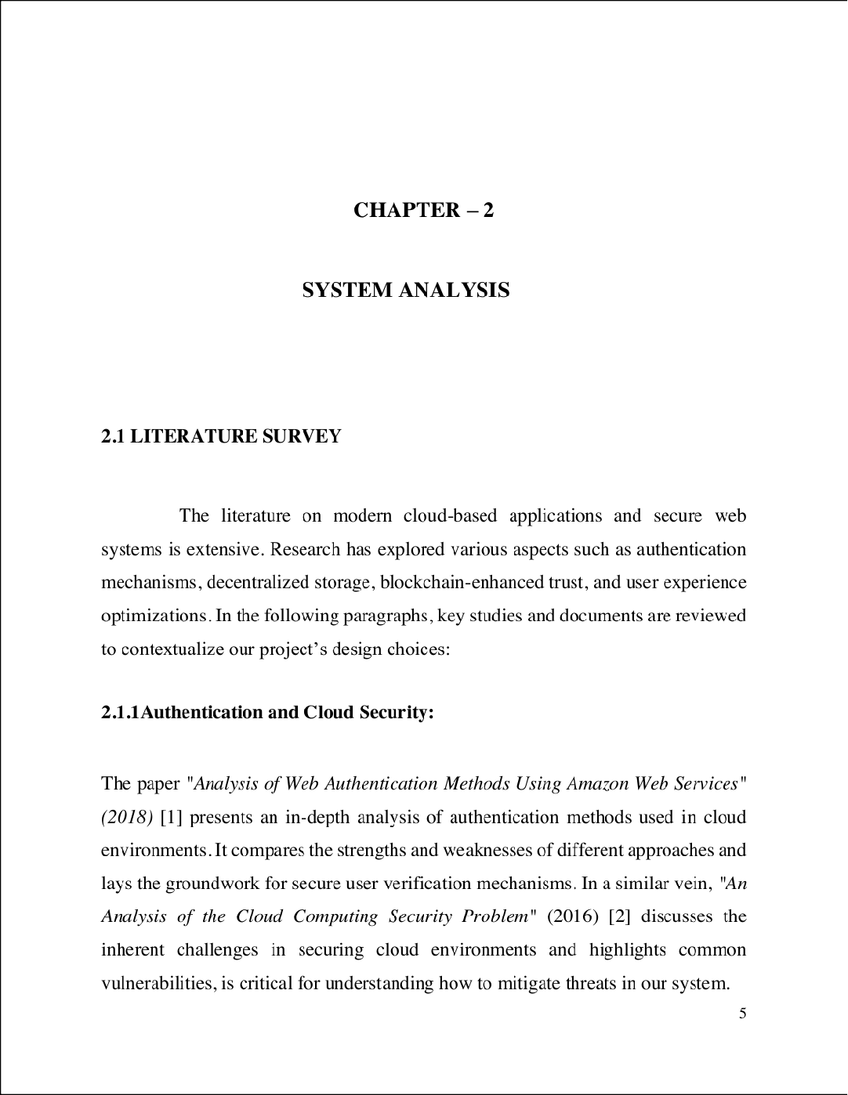

7

5

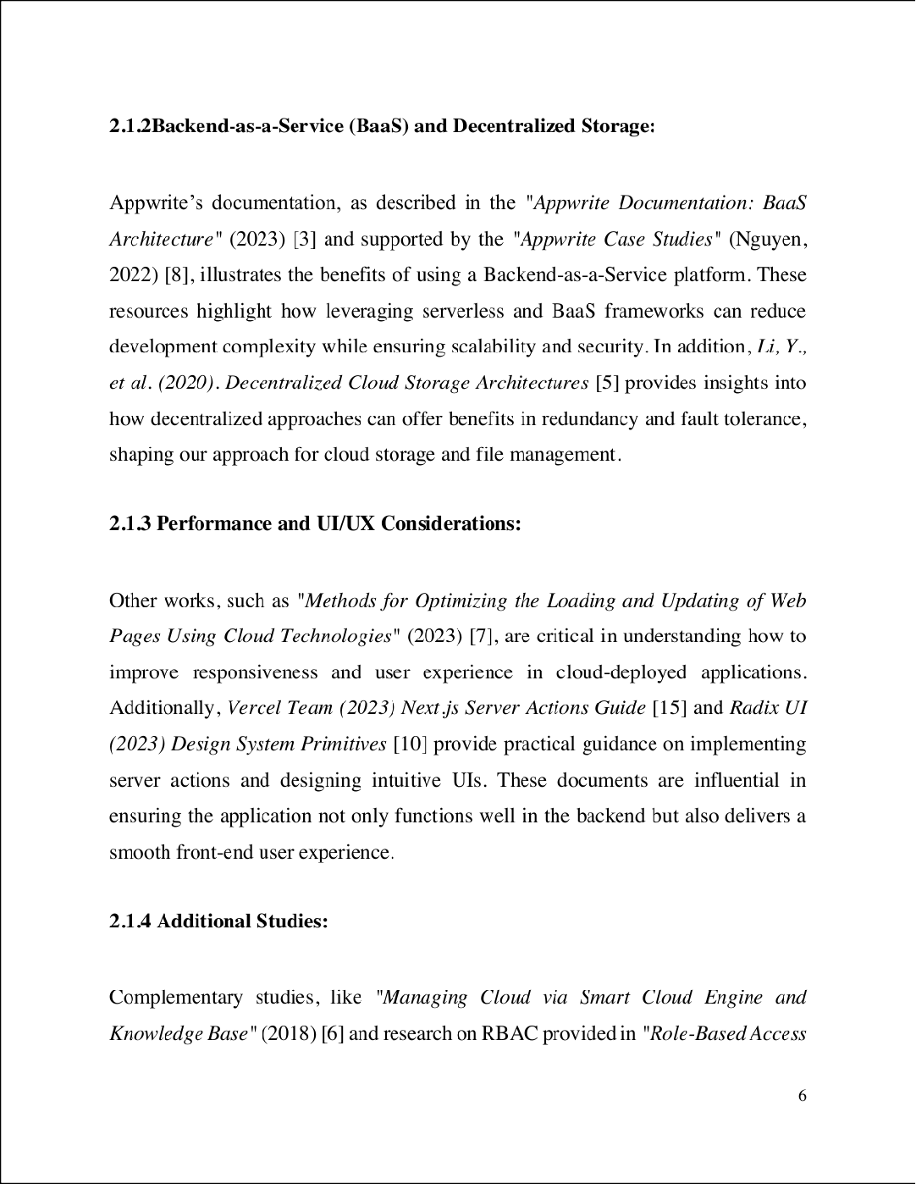

3

2

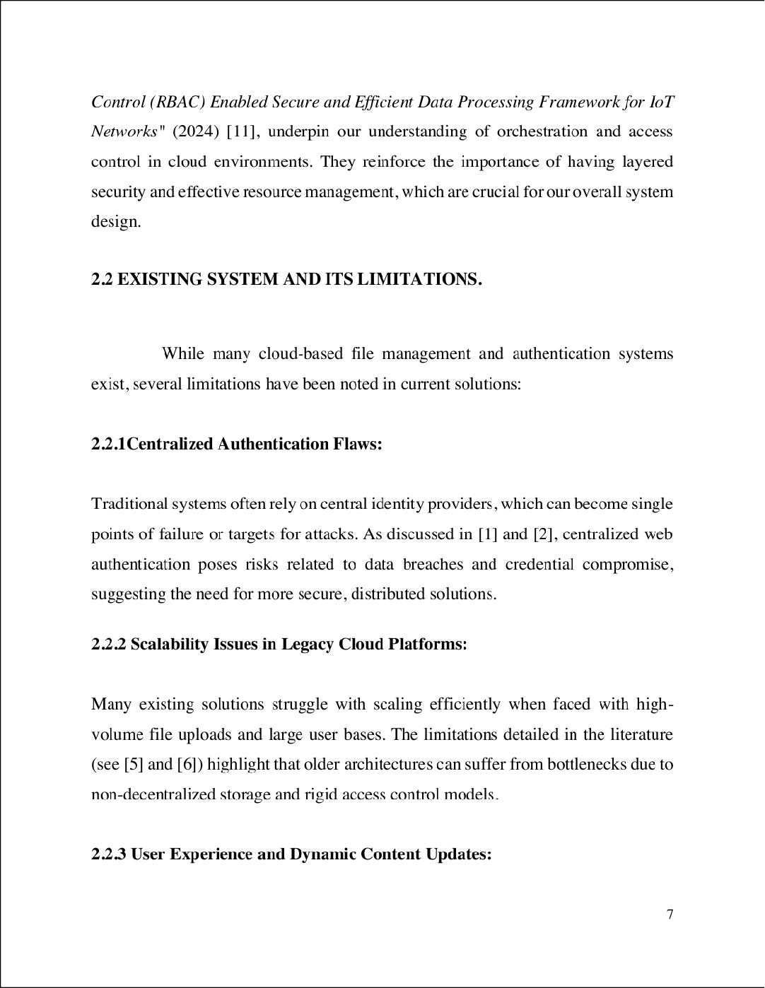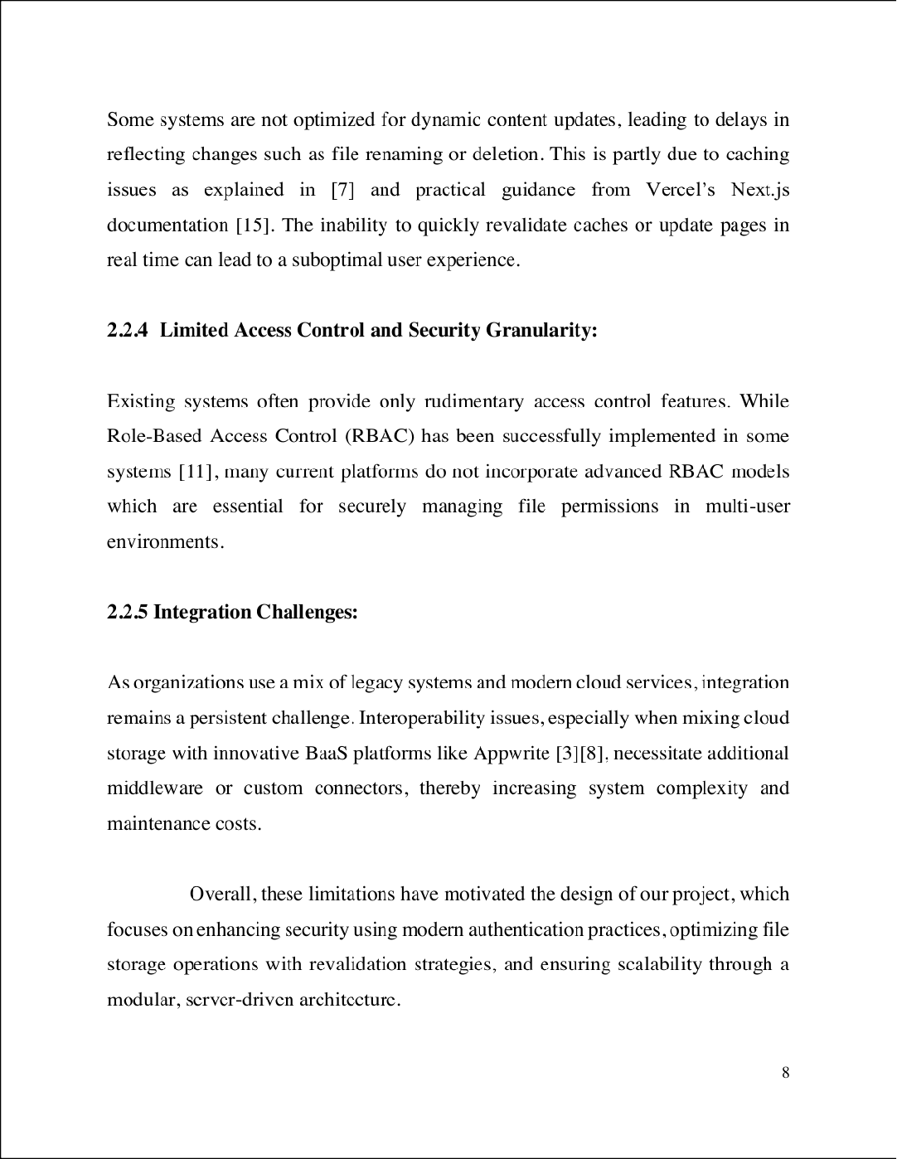

8

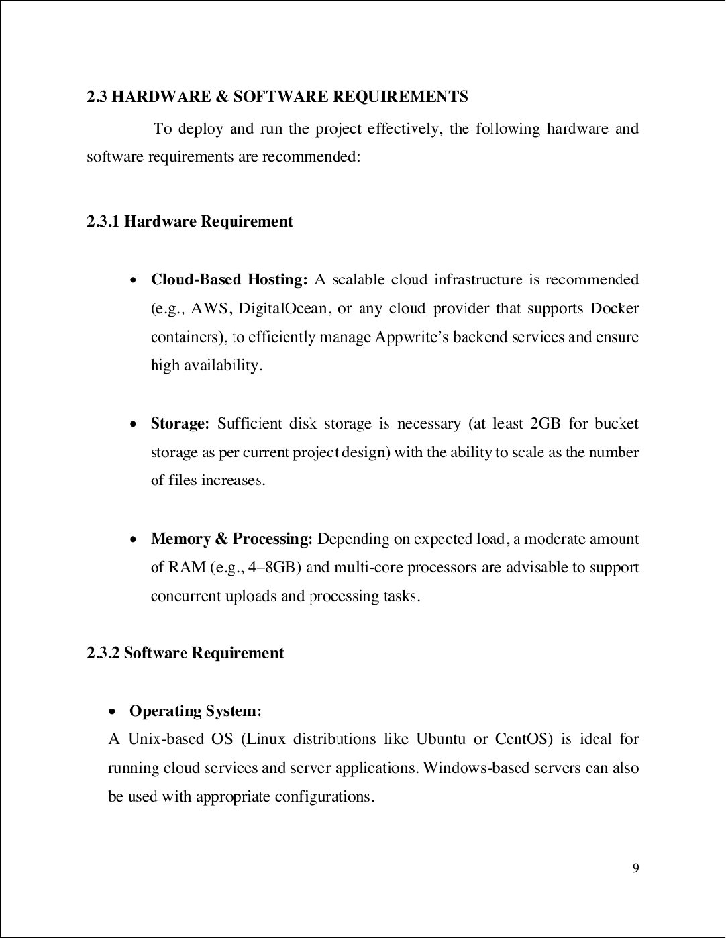

6

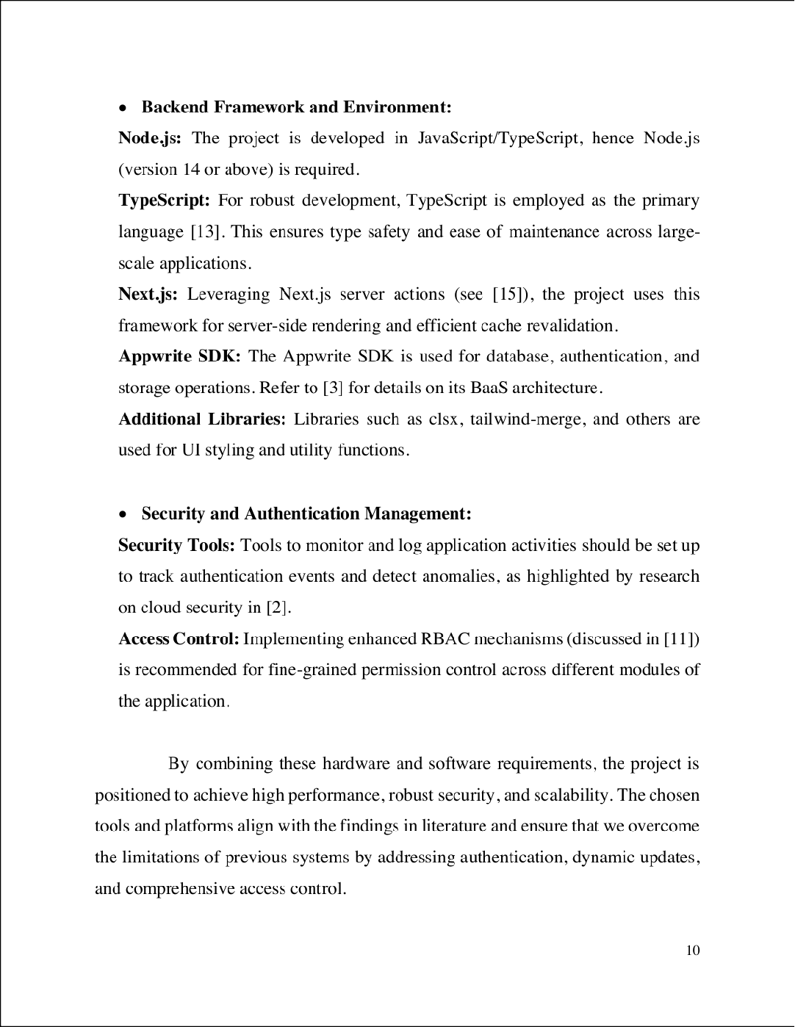

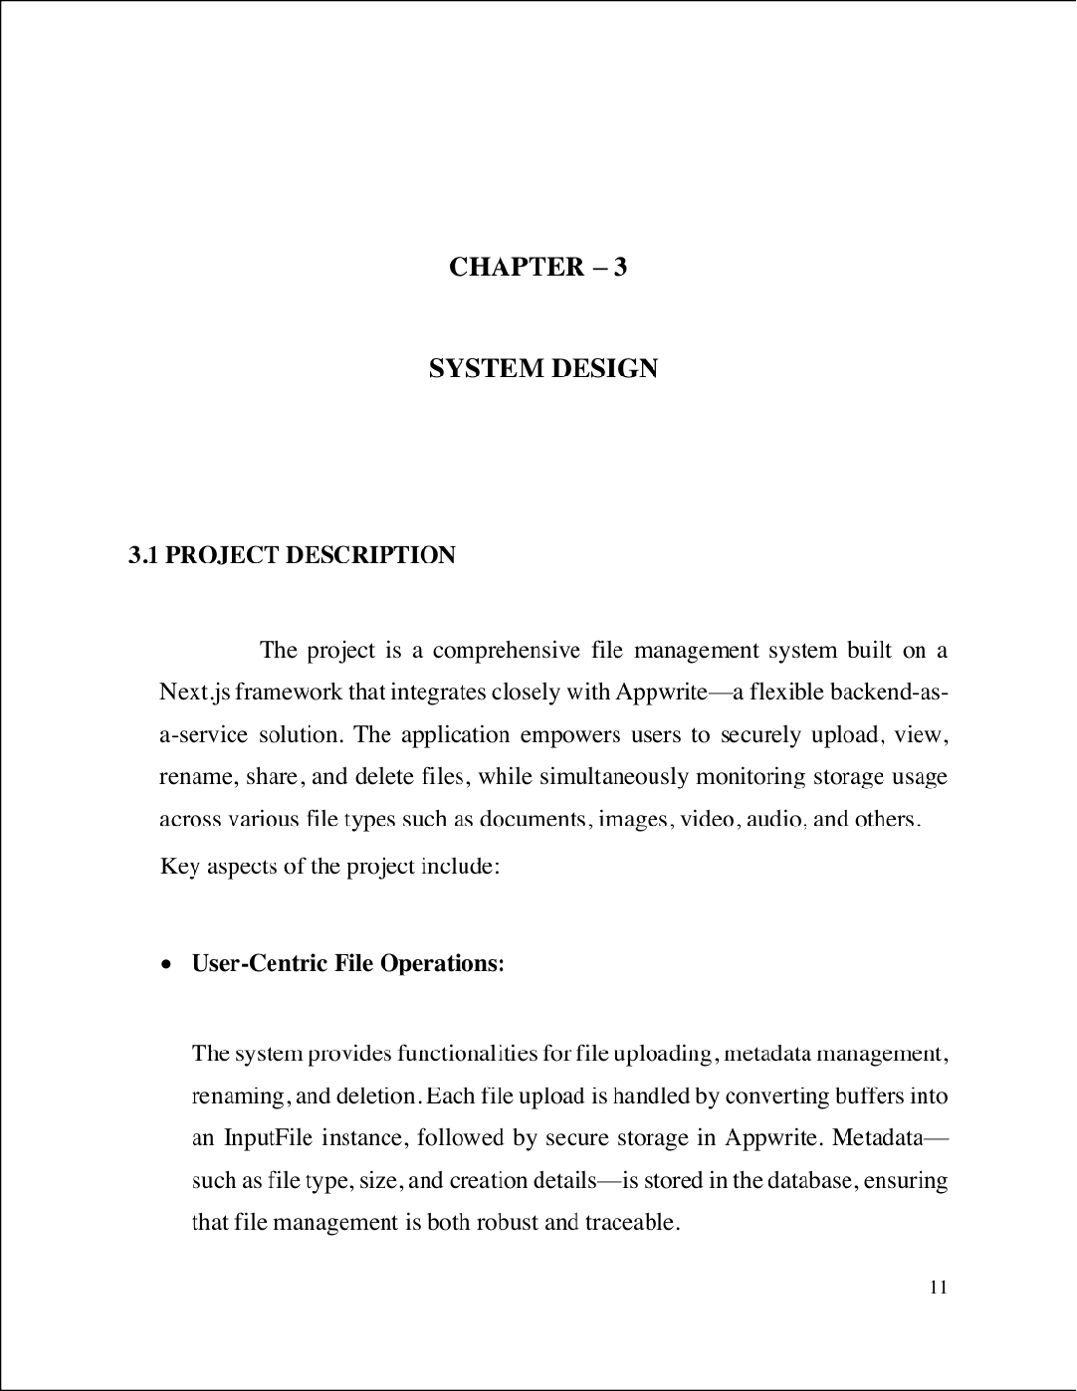

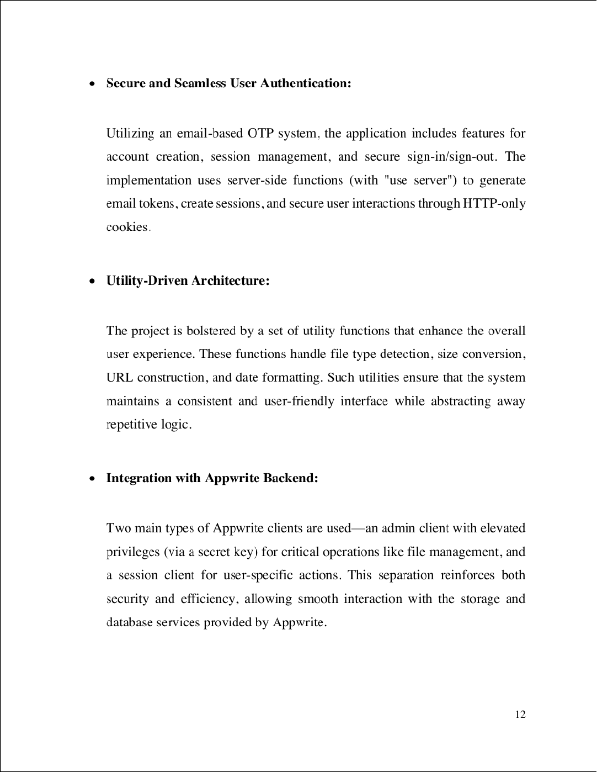

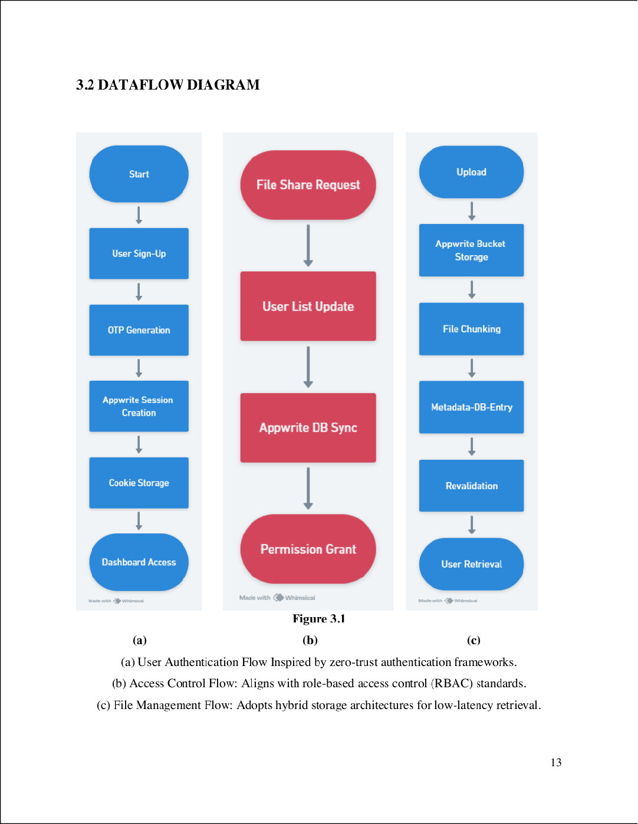

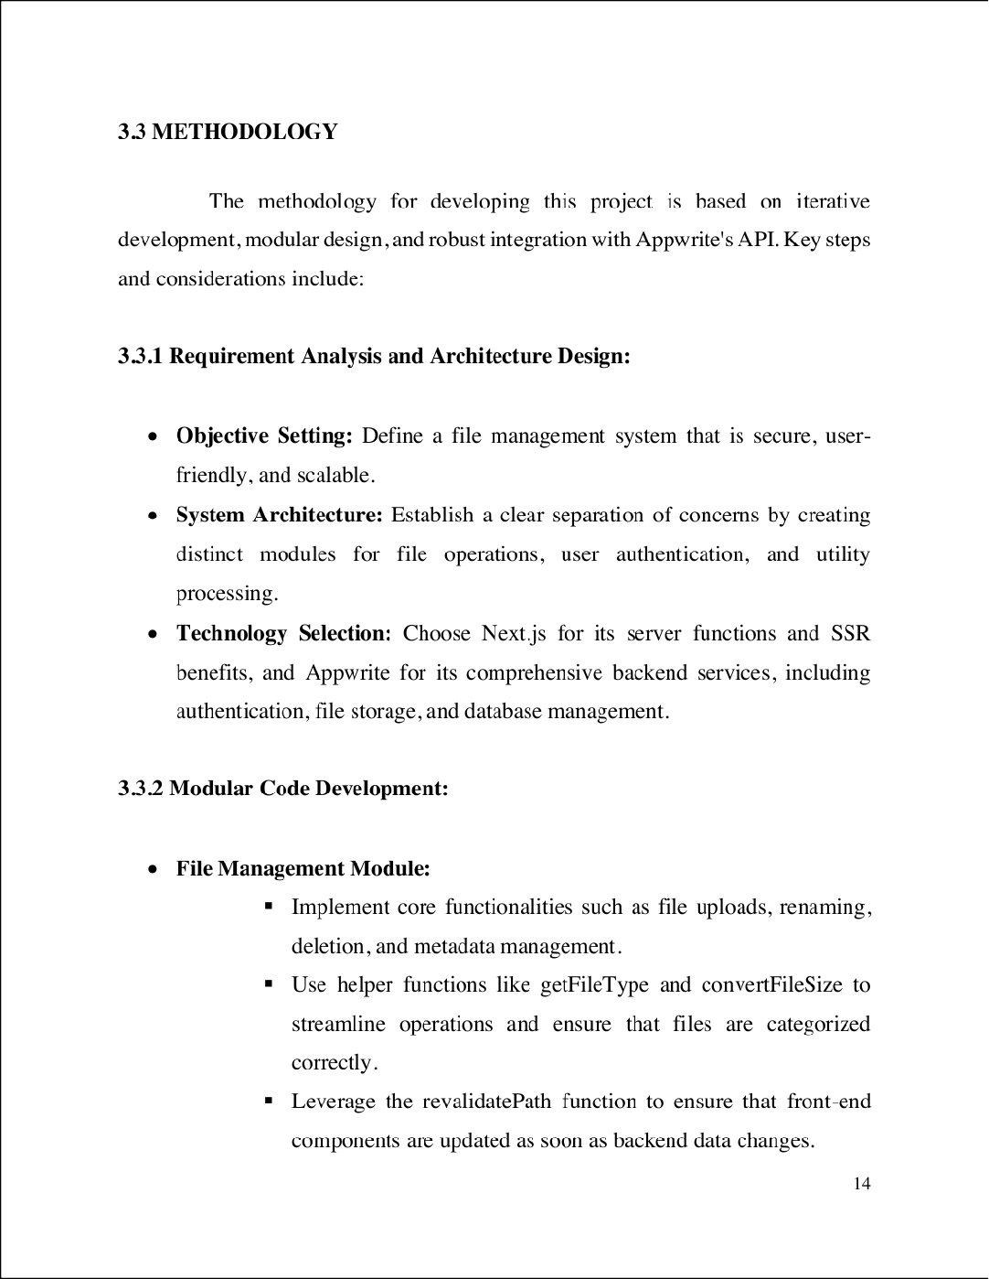

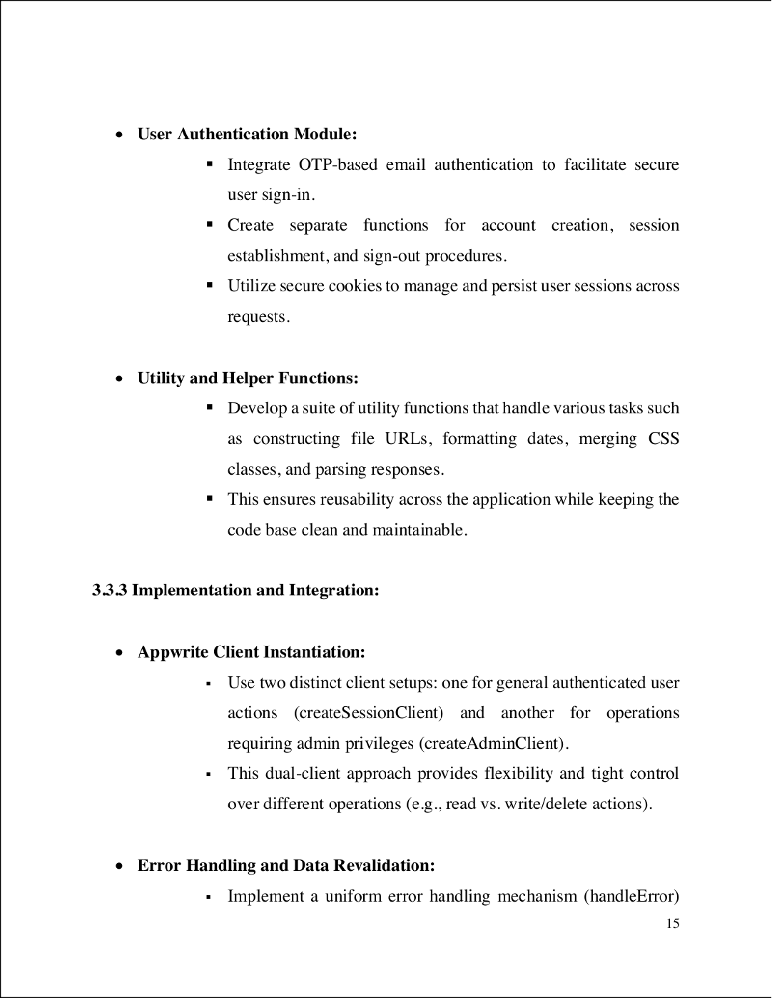

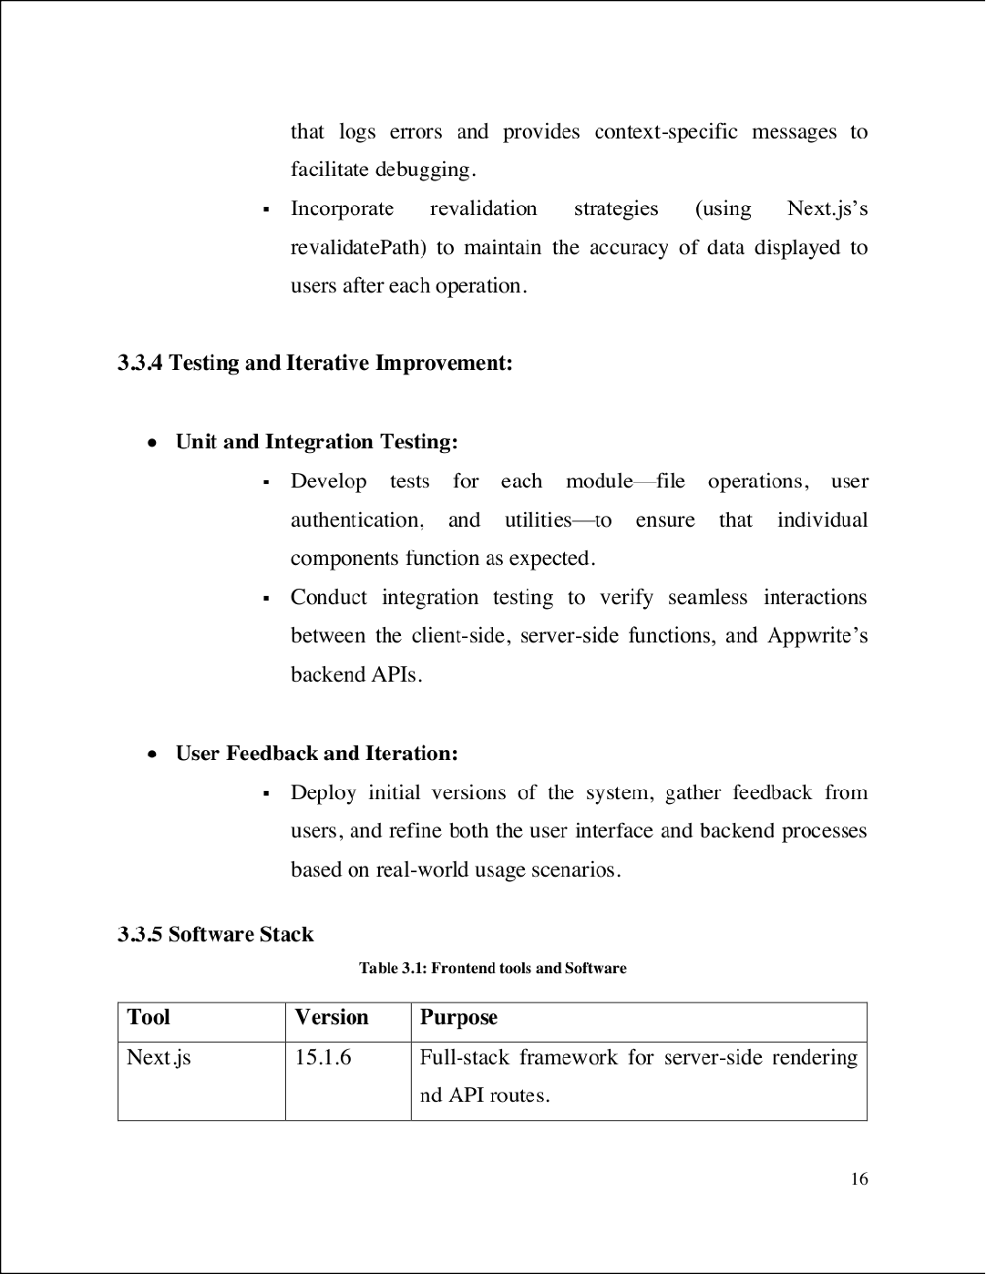

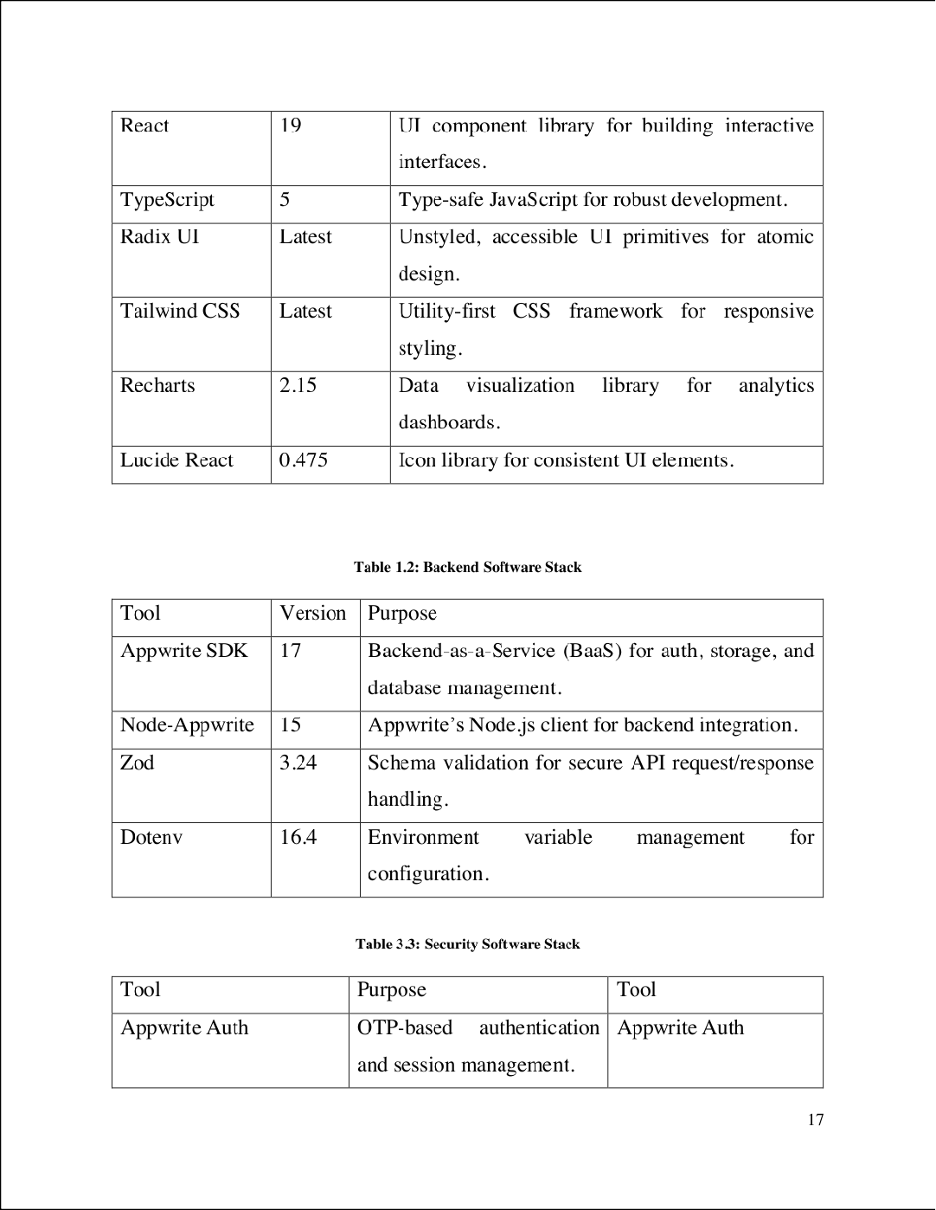

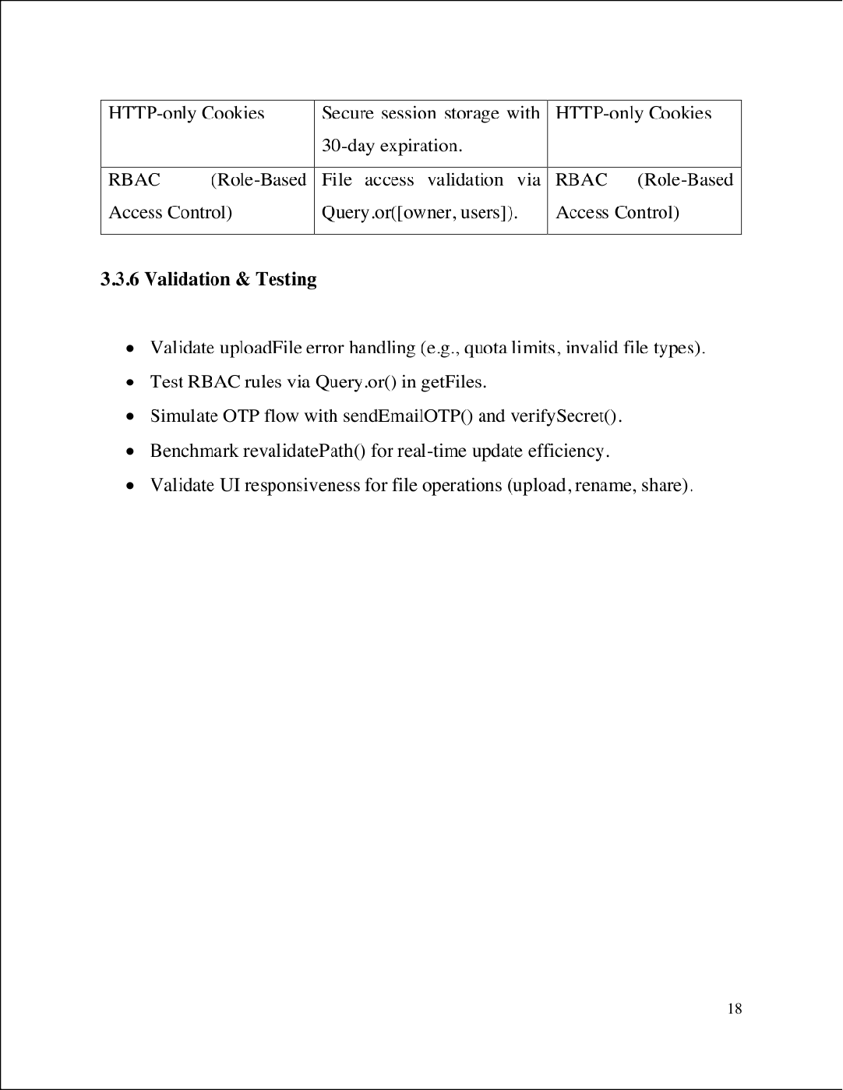

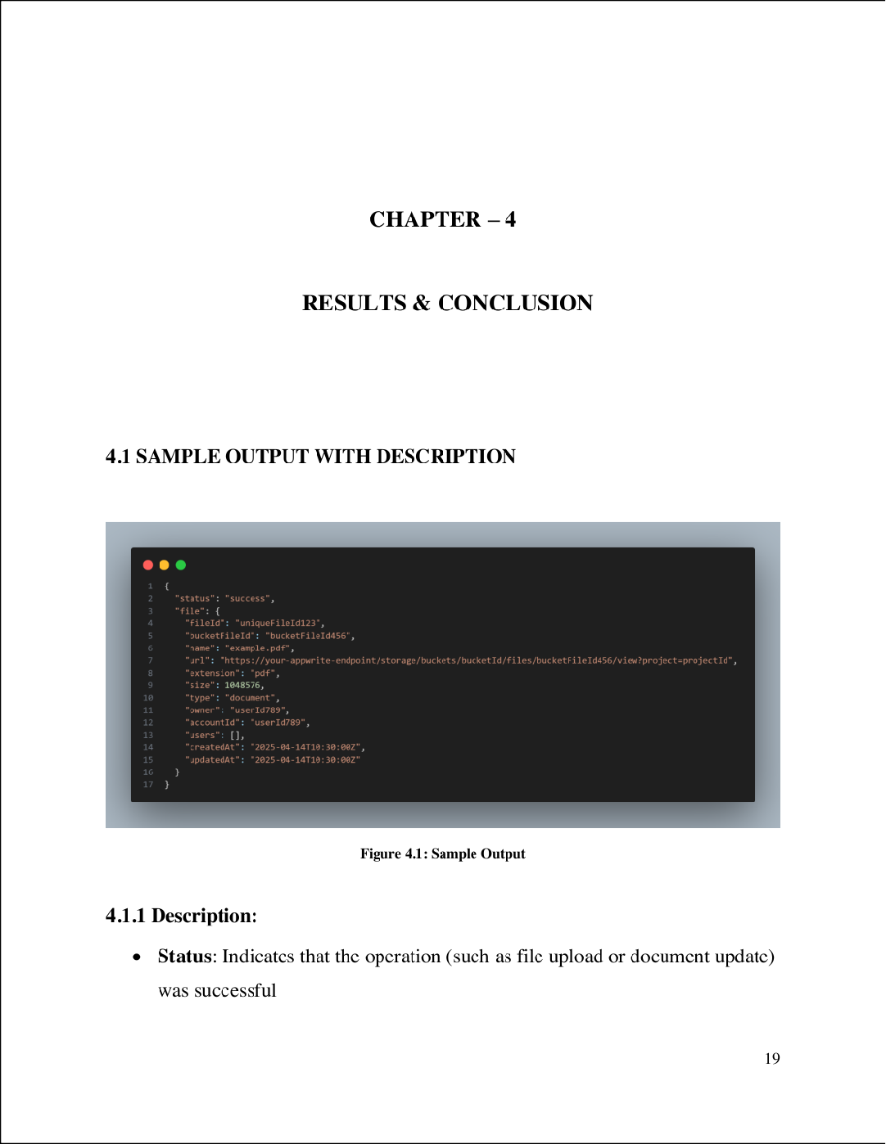

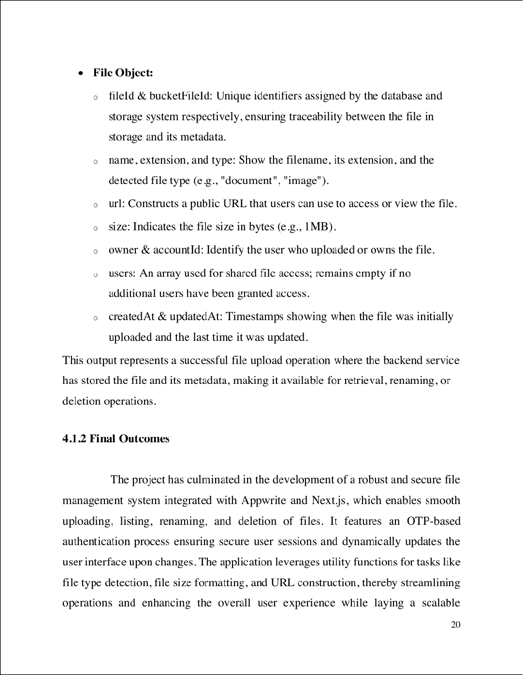

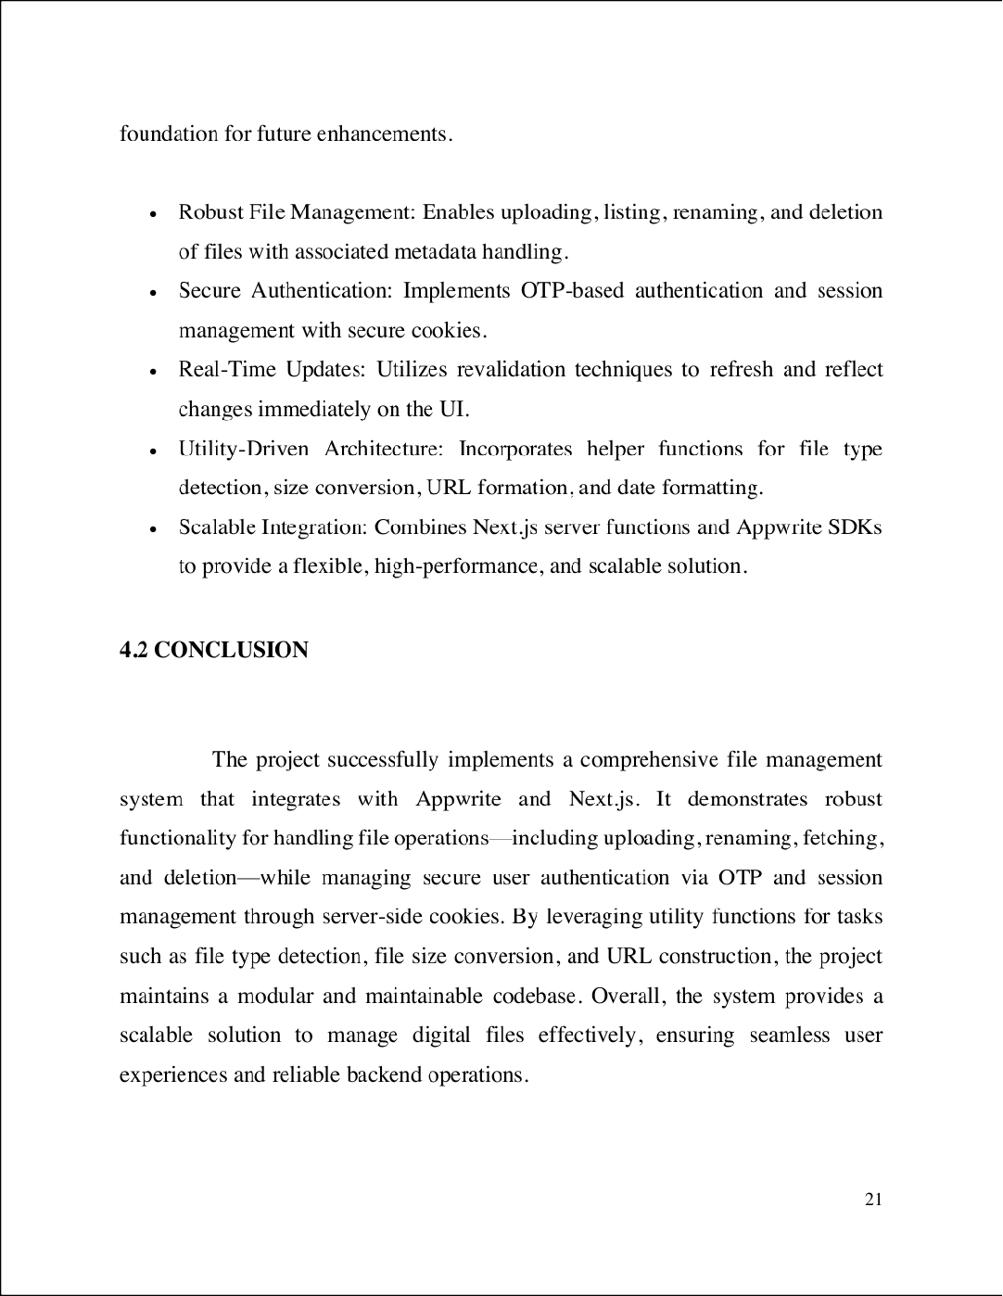

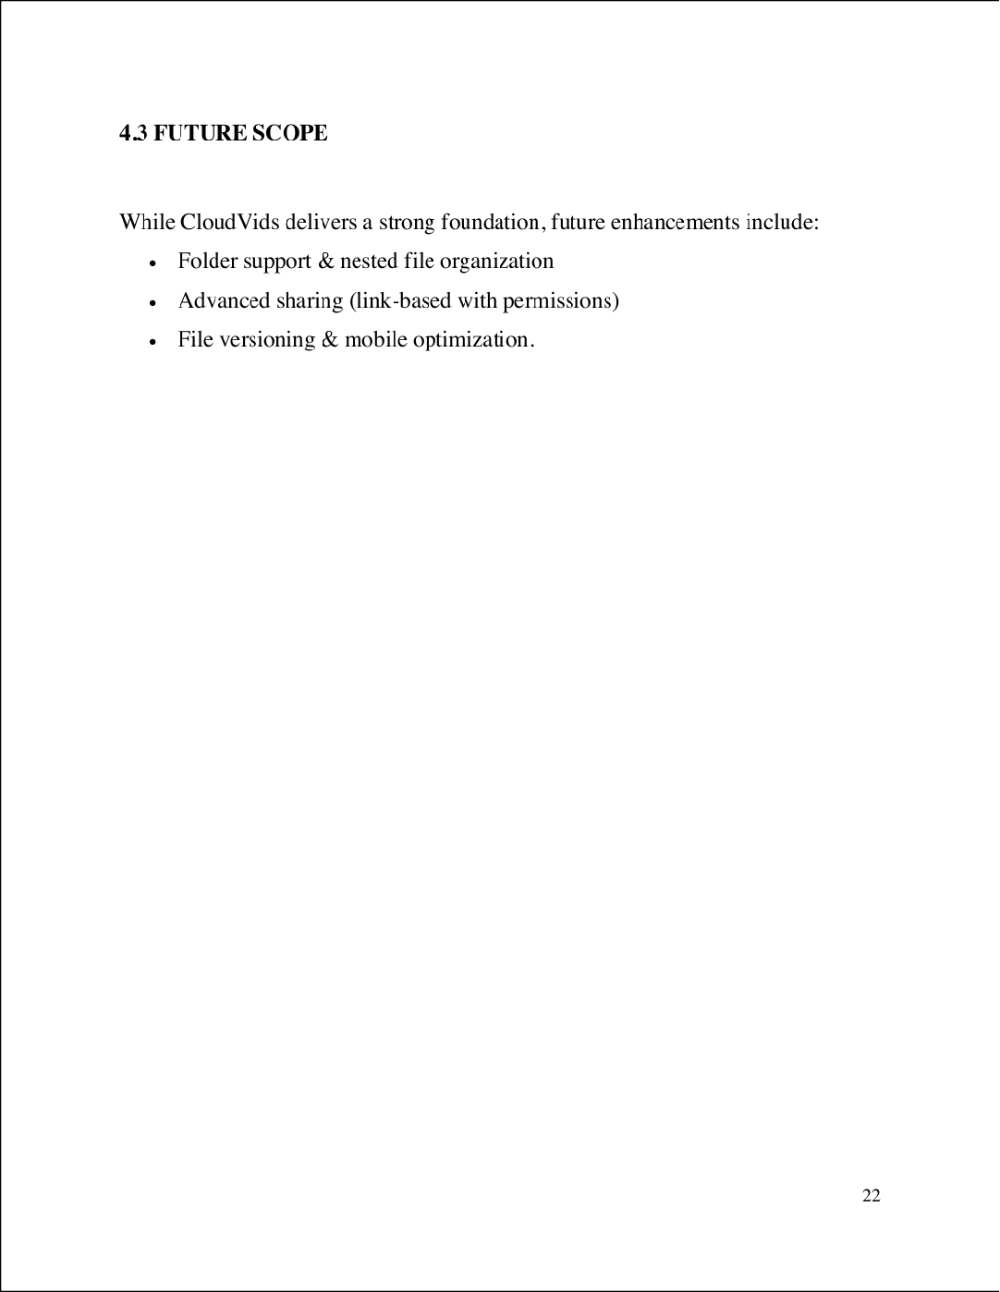

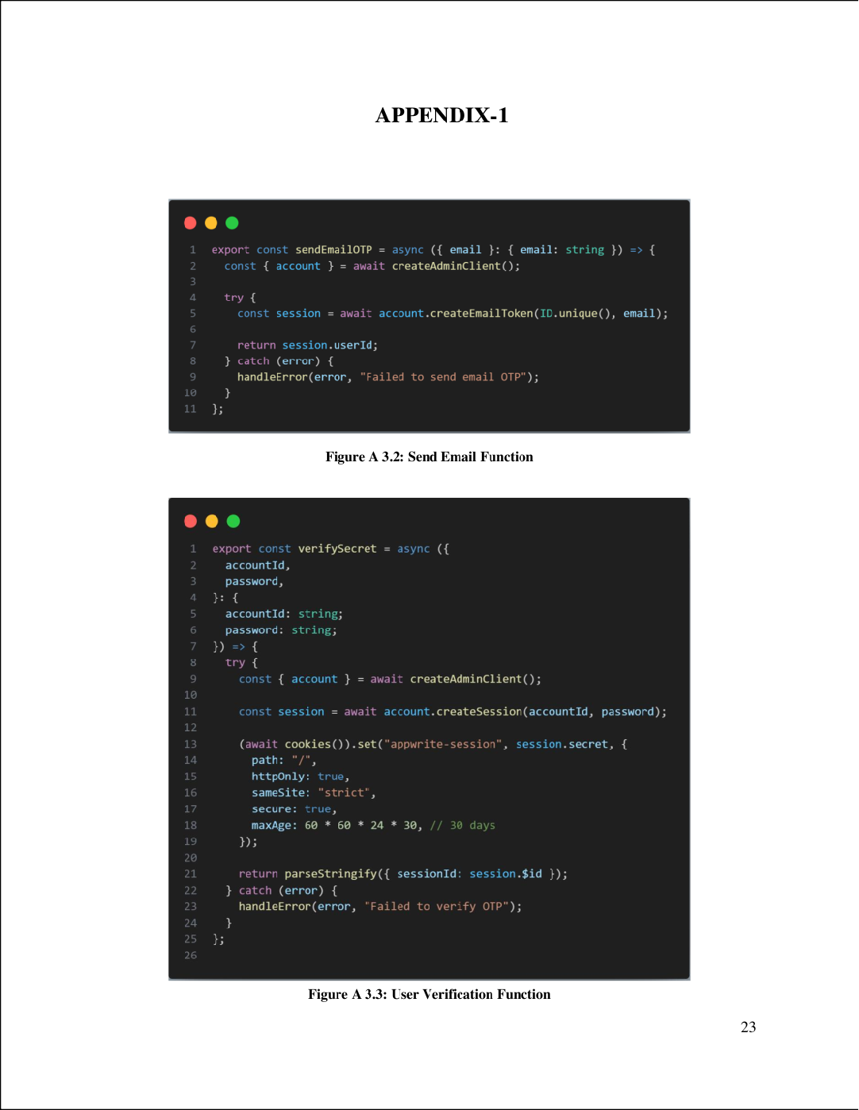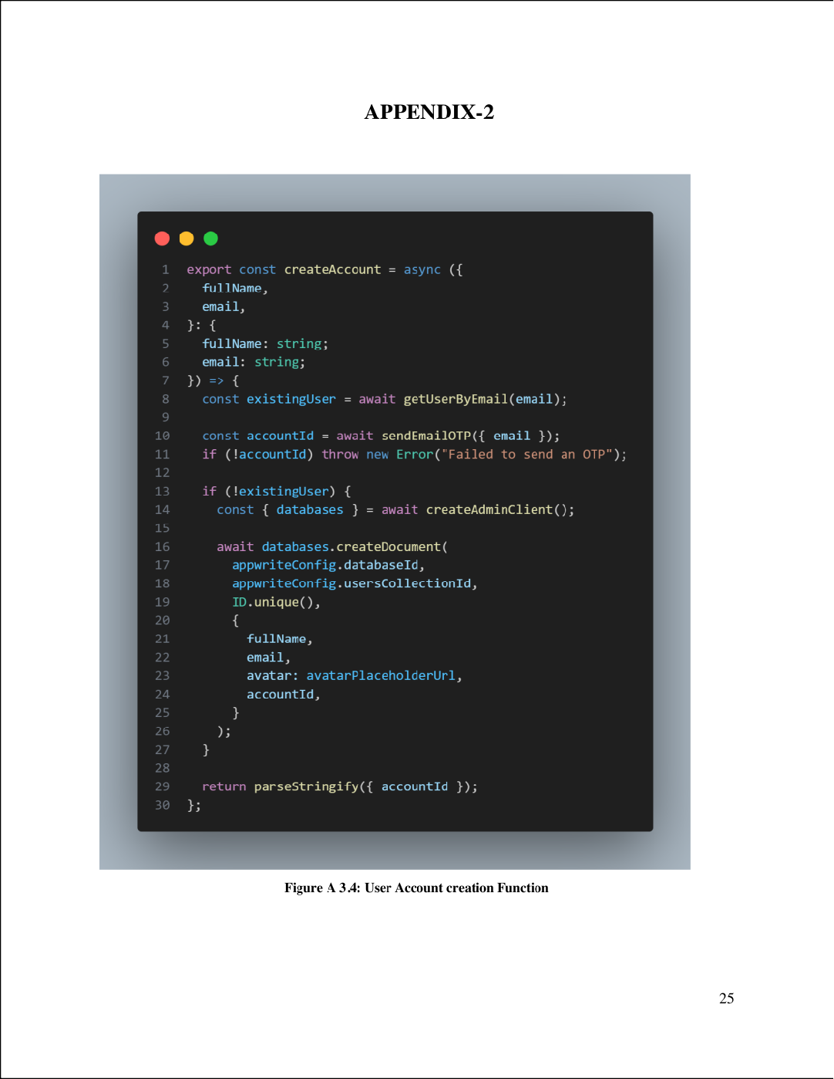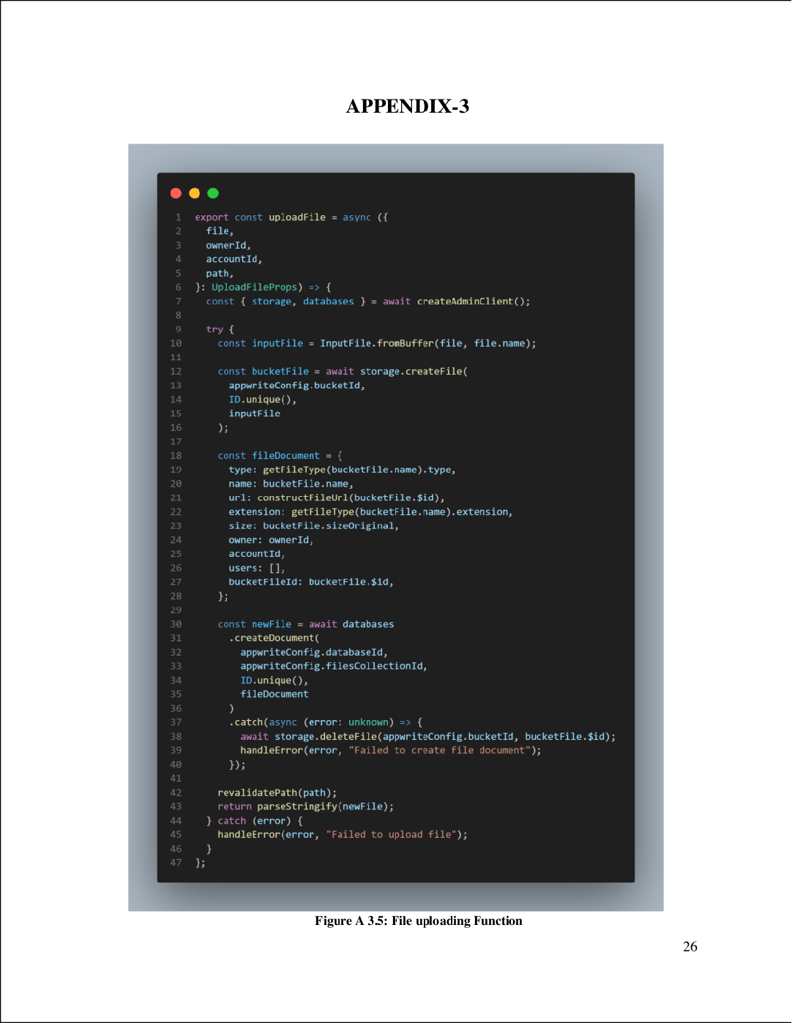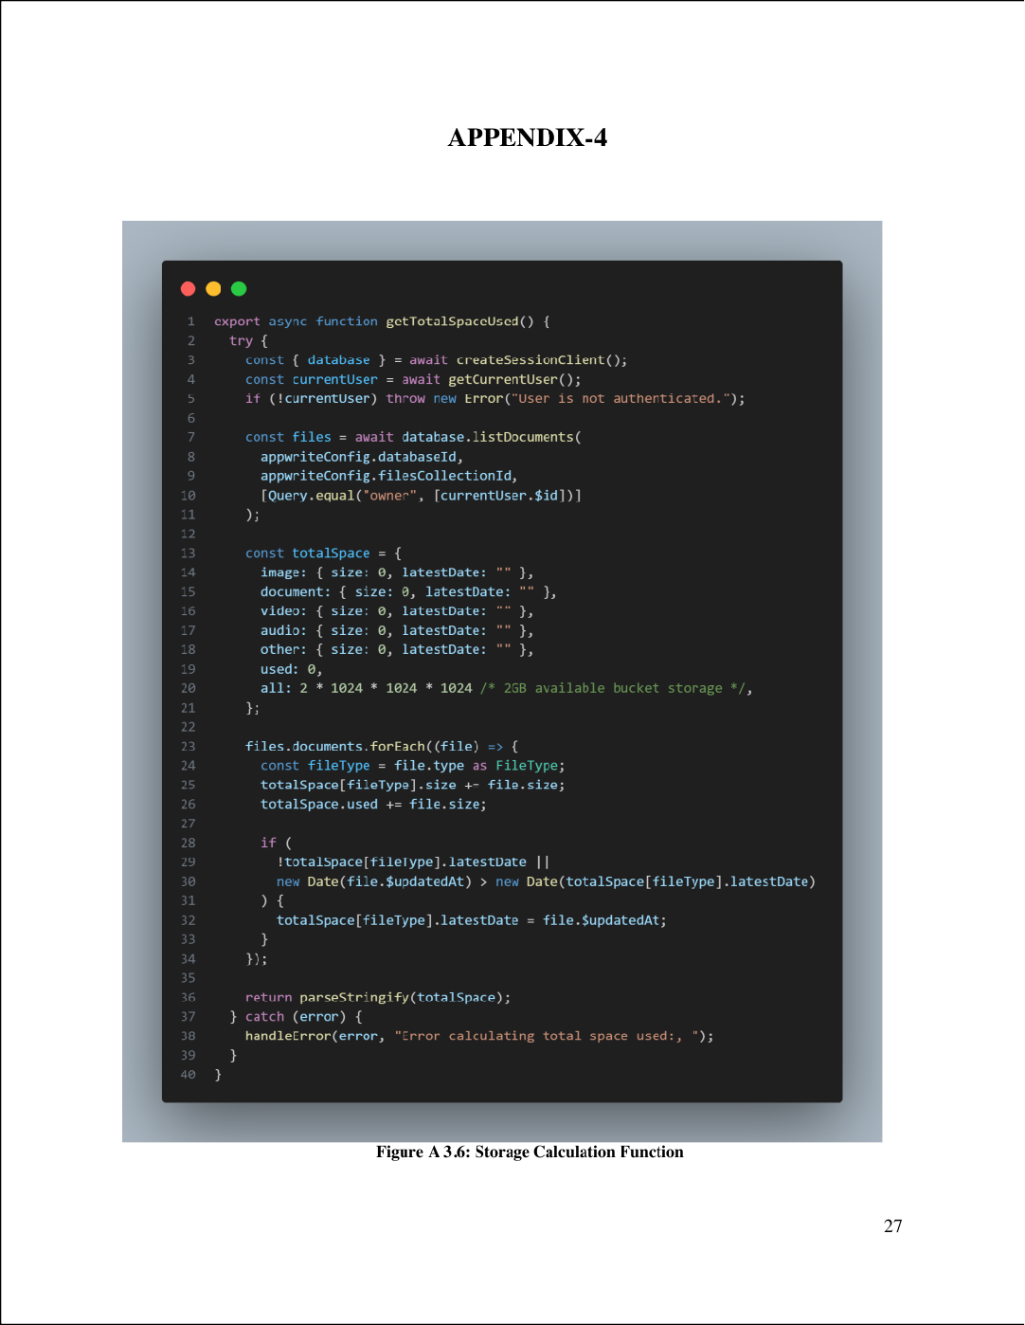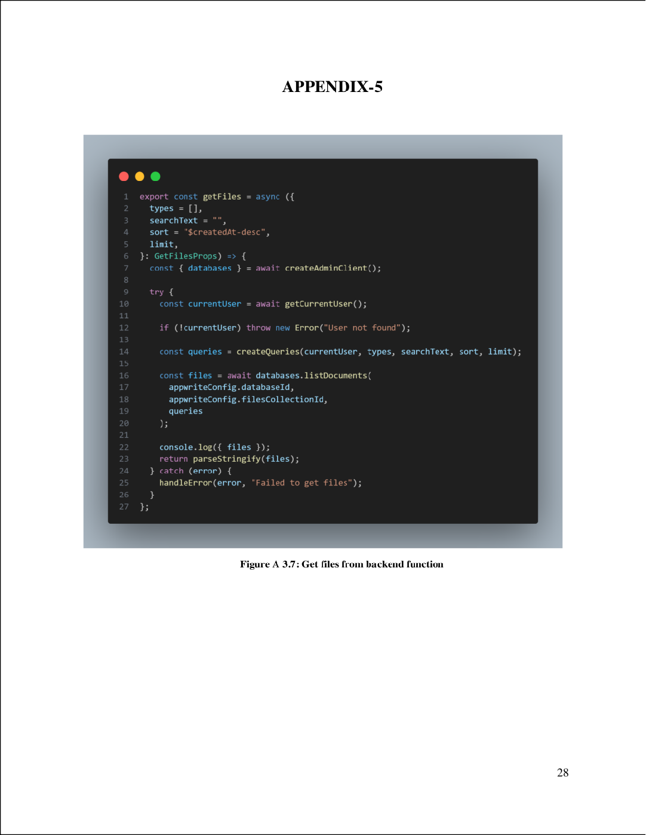

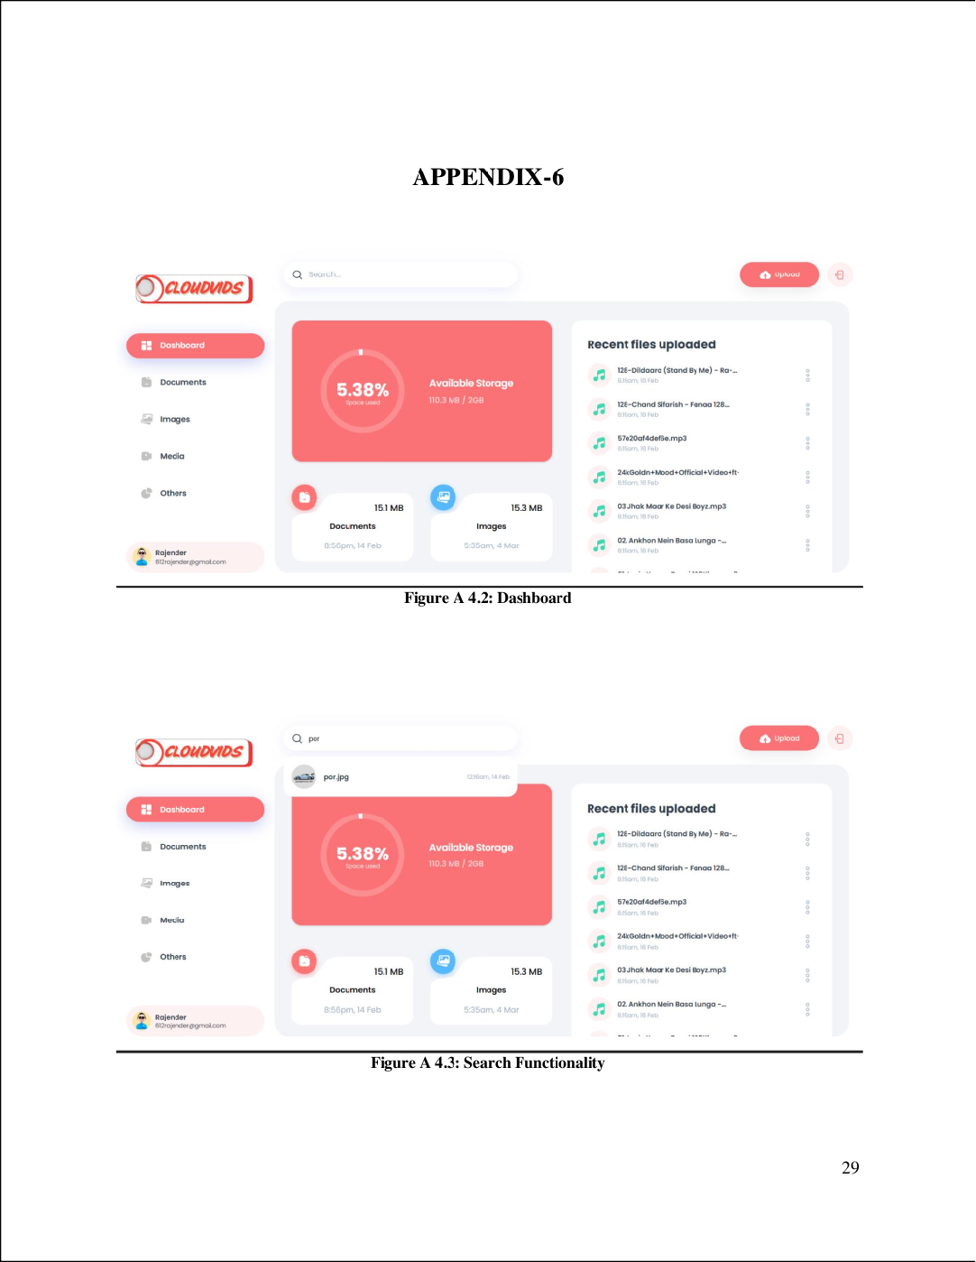

Cloudvids by Rajender

3

ORIGINALITY REPORT

%

## SIMILARITY INDEX

2%

## INTERNET SOURCES

1%

## PUBLICATIONS

0%

## STUDENT PAPERS

PRIMARY SOURCES

# bumblebee.sg

1

Internet Source

# ijcnis.org

2

Internet Source

# [www.dnu.dp.ua](http://www.dnu.dp.ua/)

3

Internet Source

# open.library.ubc.ca

4

Internet Source

# link.springer.com

5

Internet Source

6 "An approach to cloud user access control using behavioral biometric-based authentication and continuous monitoring",

International Journal of Advanced Technology

and Engineering Exploration, 2024

Publication

# pdfcookie.com

7

Internet Source

# [www.bizmanualz.com](http://www.bizmanualz.com/)

8

Internet Source

<1%

<1%

<1%

<1%

<1%

<1%

<1%

<1%

Exclude quotes Off Exclude bibliography Off

Exclude matches Off